PROJECT

* NAME :P.HARI KRISHNA
* HALL TICKET NO: 24705A0110
* BRANCH :CIVIL ENGINEERING
* YEAR :3RD B TECH
* COLLEGE :ANNAMCHARYA INSTITION OF TECHNOLOGY & SCIENCE ,RAJAMPET .

BEAM DEFLECTION CALCUTION

* Analyzes how beams bends under loads
* Input : Shear force, Bending moment , Deflection curve
* Outputs: Shear force diagram ,Bending moment diagram , Deflection curve diagram
* Libraries: numpy , matplotlib , scipy

SOURCE CODE OF PROGRAM:

import numpy as np

import matplotlib.pyplot as plt

L = 6.0

P = 10.0

a = L / 2

RA = P * (L - a) / L

RB = P * a / L

x = np.linspace(0, L, 500)

V = np.piecewise(

x,

[x < a, x >= a],

[lambda x: RA * np.ones_like(x),

lambda x: RA - P]

)

plt.figure(figsize=(8,4))

plt.plot(x, V, 'b', linewidth=2)

plt.axhline(0, color='k', linewidth=1)

plt.xlabel("Beam length (m)")

plt.ylabel("Shear Force (kN)")

plt.title("Shear Force Diagram (SFD)")

plt.grid(True, linestyle="--", alpha=0.7)

plt.show()

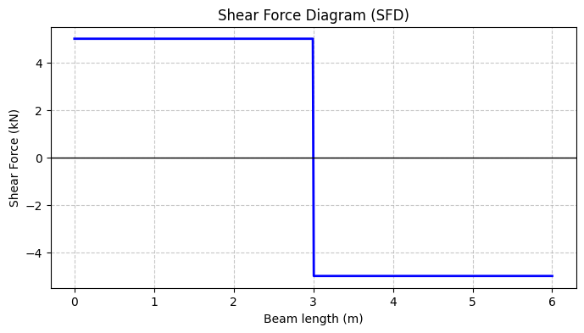

import numpy as np

import matplotlib.pyplot as plt

L = 6.0

P = 10.0

a = L / 2

RA = P * (L - a) / L

RB = P * a / L

x = np.linspace(0, L, 500)

M = np.piecewise(

x,

[x < a, x >= a],

[lambda x: RA * x,

lambda x: RA * x - P * (x - a)]

)

plt.figure(figsize=(8,4))

plt.plot(x, M, 'r', linewidth=2)

plt.axhline(0, color='k', linewidth=1)

plt.xlabel("Beam length (m)")

plt.ylabel("Bending Moment (kNm)")

plt.title("Bending Moment Diagram (BMD)")

plt.grid(True, linestyle="--", alpha=0.7)

plt.show()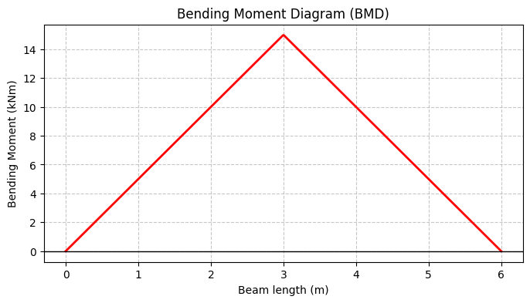

import numpy as np

import matplotlib.pyplot as plt

L = 6.0

P = 1000.0

E = 210e9

I = 8.333e-6

x = np.linspace(0, L, 500)

y = (P * x * (L**3 - 2*L*x**2 + x**3)) / (48 * E * I)

plt.figure(figsize=(8,4))

plt.plot(x, y*1000, 'g', linewidth=2)

plt.axhline(0, color='k', linewidth=1)

plt.xlabel("Beam length (m)")

plt.ylabel("Deflection (mm)")

plt.title("Deflection Diagram")

plt.grid(True, linestyle="--", alpha=0.7)

plt.show()

y_max = P * L**3 / (48 * E * I)

print(f"Maximum deflection at midspan = {y_max*1000:.4f} mm")

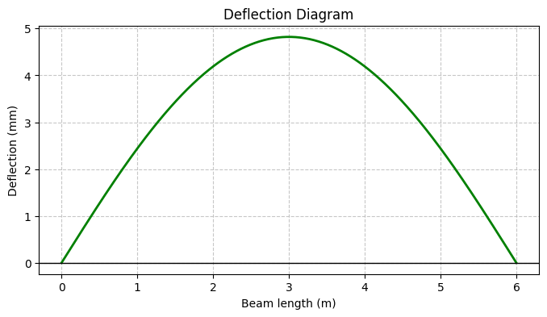

CONCLUSION:

The **Shear Force Diagram** , **Bending Moment Diagram** , and **Deflection curve** successfully excuted the behavior of beams under different loading and support conditions.By using the python programming and graphical representation had been excuted successfully.